全国2011年1月自学考试高级英语试题
课程代码：00600

请将答案填在答题纸相应位置上，全部题目用英文作答（英译汉题目除外）
I. The following paragraphs are taken from the textbooks, followed by a list of words or expressions marked A to Y. Choose the one that best completes each of the sentences and write the corresponding letter on your Answer Sheet. One word or expression for each blank only. (25 points, 1 point for each)
West Germany, by contrast, will not be able to 1 any form of euthanasia for a long time to come. Opposition is 2 fierce, because of the shadow of the past. Countries 3 an uninterrupted recent libertarian tradition have less to fear from setting some 4 rules for voluntary euthanasia. By 5 to discuss it, they usher in something worse.
We watched while pride allowed unimportant battles to be 6 into the most important stands of the war－because we couldn’t 7 and we couldn’t retreat and because it didn’t matter how many American 8 were provided to prove that point. Now we are told that we have to 9 quietly while the American lives are lost so that we can exercise the 10 arrogance of Vietnamizing the Vietnamese.
Newspapers have two great advantages 11 television. They can be used by men as barriers
12 their wives. It is still the only effective screen against the morning features of the loved one, and, as such, performs a unique human 13 . The second advantage is that you can’t line a
14 pail with a television set—it’s usually the other way 15 .
It is only lately that I have found how much science of genetics is 16 . Agronomists and the like have taken to 17 all sorts of vegetables and fruits－changing their 18 nature. This sounds wonderful and often is 19 . For the scientists have not as a rule taken any 20 whatsoever in the taste of the things they’ve tampered with!
My own lack of shame in the rioting then taking place in America 21 me. In one sense, I was the 22 of the ghetto child who through hard work and initiative was 23 himself toward a better life. I was the 24 , the exception. It was my life that was held up to Watts youth to 25 .

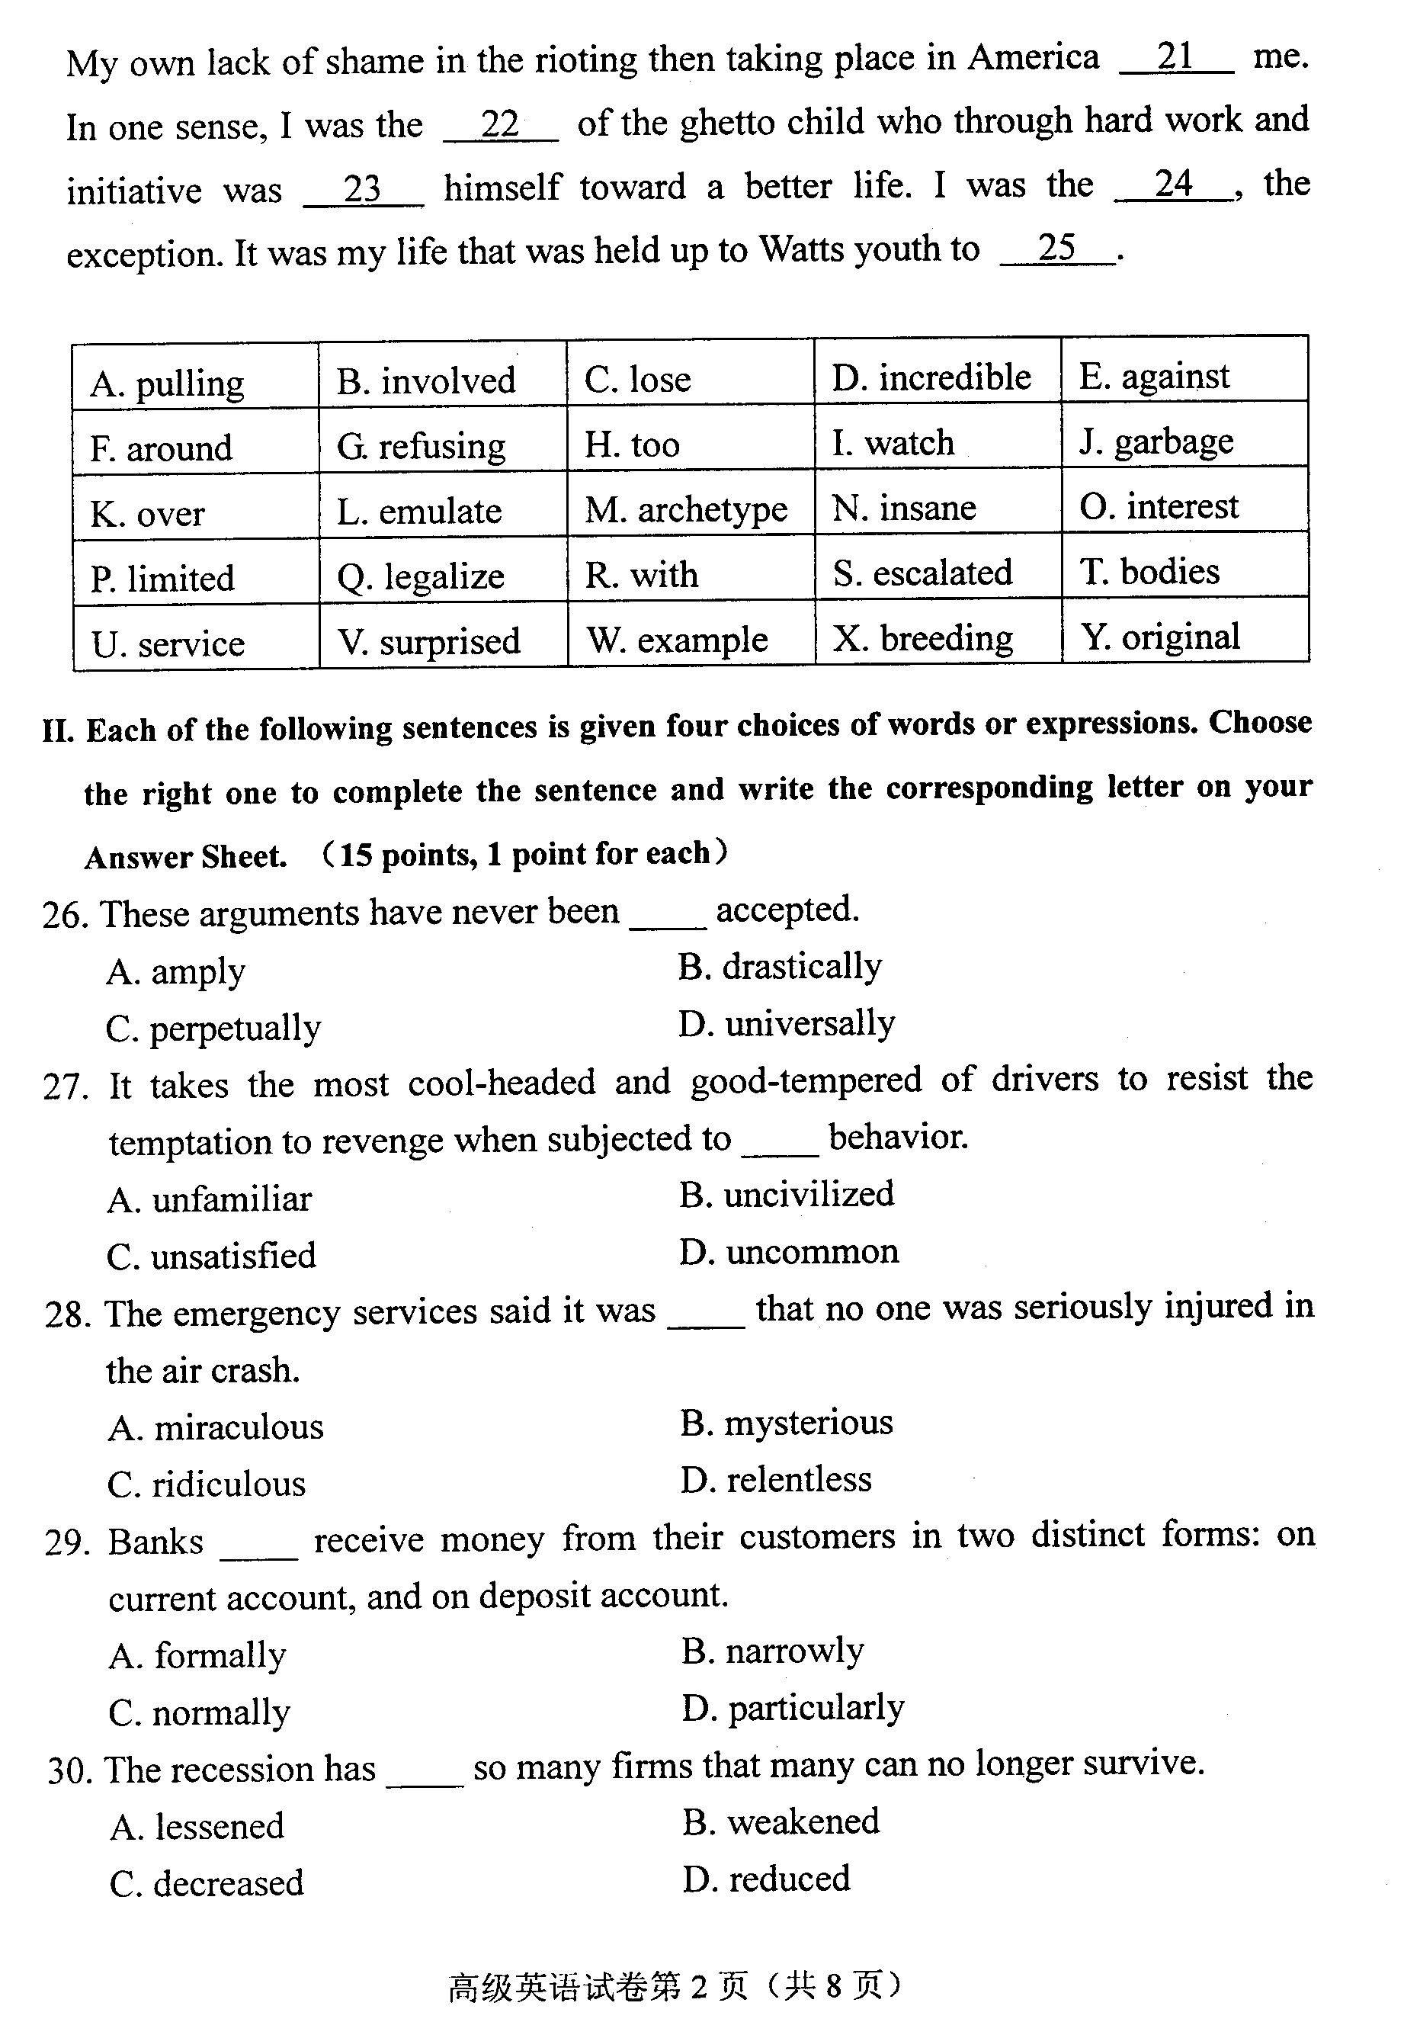
II. Each of the following sentences is given four choices of words or expressions. Choose the right one to complete the sentence and write the corresponding letter on your Answer Sheet. (15 points, 1 point for each)
26. These arguments have never been _________ accepted.
A. amply B. drastically
C. perpetually D. universally
27. It takes the most cool-headed and good-tempered of drivers to resist the temptation to revenge when subjected to _________ behavior.
A. unfamiliar B. uncivilized
C. unsatisfied D. uncommon
28. The emergency services said it was _________ that no one was seriously injured in the air crash.
A. miraculous B. mysterious
C. ridiculous D. relentless
29. Banks _________ receive money from their customers in two distinct forms: on current account, and on deposit account.
A. formally B. narrowly
C. normally D. particularly
30. The recession has _________ so many firms that many can no longer survive.
A. lessened B. weakened
C. decreased D. reduced
31. In science, a theory is a reasonable __________ of observed events.
A. explanation B. excavation
C. expression D. evaluation

32. Children do not learn what it is to lose and will __________ violence to release their
disappointment.
A. refer to B. attribute to
C. point to D. resort to
33.A sincere __________ is like the sunshine which can boost our morale.
A. compliment B. supplement
C. accomplishment D. complement
34. He was arrested when his __________ scheme to evade taxes came to light.
A. fake B. fraudulent
C. false D. foreign
35. This old room has not been much in use of late. No wonder it has such a_______ appearance.
A. vulgar . B. fancy
C. shabby D. cheap
36. That little boy was so naughty that he tried to _________ feathers from a chicken.
A. flick B. twist
C. pluck D. toss
37. The task of a teacher _________ patience and conscientiousness.
A. commands B. demands
C. amends D. mends
38. She gave us unfailing _________ and became an essential part of our family.
A. devotion B. inspection
C. exploration D. indication
39. As we were saying goodbye, the train started with a_________.
A. shake B. shiver
C. tremble D. jerk
40. Parents should attach importance to their children’s _________ from adolescence to adulthood.
A. permission B. position
C. transmission D. transition

Read the following passage carefully and complete the succeeding three items III, IV, V.

Why I Came to College
(1) Why have I chosen to attend college? I have put this question to myself at many times and in various forms during the past three and a half months which have constituted the first semester of my freshman year. Have I come because of parental influence, or because I have some goal of my own that I wish to pursue? After pondering these questions on many occasions, I have finally reached the conclusion that I have come to college not for one single reason, but for many, and that it is something that I truly want to do.
(2) Originally, my parents did influence my opinions about education in general. My mother, an elementary school teacher, was always proud of my academic successes, but she never really pushed me or demanded that I achieve excellent grades. However, from the beginning of my schooling, my parents seemed to assume that I would attend college, and by the time I reached high school, I had become accustomed to that idea as well.
(3) When I entered high school, I enrolled in the college preparatory program offered there, looking ahead four years to college attendance. However, as I proceeded further through high school into my junior and senior years, I became genuinely interested in many of the subjects which I was studying. Chemistry, physics, and calculus were the courses which held my interest most strongly and I felt that I wanted to continue to study those areas beyond the high school level. Up to that point in my life, I had always claimed that I wanted to attend college. but didn’t realize why until my high school career drew to a close.
(4) Finally, I began to recognize in myself a strong drive to obtain knowledge. I knew that I would not be content to simply end my educational career with high school and enter the working world. I truly felt a need to continue learning in order to gain a better understanding of the world around me. My final decision to attend college seemed a natural one, and my choice of engineering as a field of study came easily as well, since the profession fit well with my academic preferences.
(5) The fact that I enjoy learning and gaining knowledge was my main reason for choosing to enter college, but I must admit that it was not the sole reason. In today’s world, a college education has become almost essential if one wishes to compete in the job market. In the next several years, this trend will surely continue, with a Bachelor’s degree becoming almost indispensable if one wishes to find a worthwhile position, and a Master’s degree becoming highly desirable for advanced positions. Although it may sound materialistic, I felt that attending college was a practical and necessary step which I took to ensure a secure future for myself and my family. I made my choice to study engineering primarily on the basis of my love of mathematics and the physical sciences; however, the fact that it is a well-paid and respected profession did have some influence on my final decision to study engineering, rather than a pure science curriculum. Either field would have allowed me to study those subjects which hold my interest, but the decision to pursue the one which would ultimately be more profitable was not a difficult choice to make.
(6) A third reason that I am attending college is that I have always hoped that I could make a contribution to the world. I knew that a career involving science and technology would give me the best opportunity to do this. I also knew that in order to pursue such a career, I would be required to go through college. Hopefully, this will enable me to someday make a contribution to the expansion of the frontiers of society’s knowledge, and to in some way benefit mankind.
(7) Finally, I chose to attend a diversified college, as opposed to a purely technical institute, because I feel that college should allow a person to grow in areas other than pure academics. It should also expose that student to a variety of social and political ideas, helping to expand his mental horizons. Attending Rutgers University has definitely allowed me to come into contact with a wide variety of lifestyles which could only be found together on a collegiate campus. Additionally, while I am able to major in a scientific field at Rutgers, I am able to simultaneously take courses which explore other fields of study and allow me to become a more diversified and well-rounded person. This overall gain of general knowledge which is available only to the college student is another reason that I was lured toward the pursuit of a higher education.
(8) Thus, I came to college not for one reason, but for several different ones. It was something that I had planned, even without fully knowing why, for several years. It was certainly the next logical step in my educational career after the completion of high school. However, only in my final two years of high school did I actually begin to recognize in myself the inherent desire to obtain information and learning which pursue the other goals which I had set for myself. I also knew that I wanted to become a more diversified person, and that a college education was the best means to attain that end.
(9) Why have I chosen to attend college? Sometimes I am unsure of the exact reason myself. I am sure, however, that it is what I should do and what I want to do with the next four years of my life.
III. In this section, there are ten incomplete statements or questions, followed by four choices marked A, B, C and D. Choose the best answer and write the corresponding letter on your Answer Sheet. (20 points, 2 points for each)
41. According to the passage, the author came to college mainly __________.
A. out of his own will B. because of social pressure
C. out of respect for his parents D. because of financial attraction
42. The word “pondering” in Paragraph l can be best replaced by __________ .
A. answering appropriately B. exploring thoroughly
C. dealing with efficiently D. thinking carefully about
43. According to Paragraph 2, which of the following is true about the author’s parents?
A. They were demanding.
B. They were open-minded.
C. They were indifferent to his future.
D. They were anxious about his future.
44. Which of the following is closest in meaning to the word “genuinely” in Paragraph 3 ?
A. really B. completely
C. immediately D. finally
45. It can be inferred from Paragraph 5 that _________ .
A. few people study for Bachelor’s degrees
B. a college degree means more than ever before
C. college education is required for a good future
D. a Master’s degree can guarantee advanced positions
46. Which of the following can best explain the word “indispensable” in Paragraph 5?
A. ingenuous B. essential
C. advantageous D. helpful

47. The author chose engineering mainly because _________ .
A. it was more popular B. he could make more money
C. he was more interested in it D. he could be more successful
48. College education was expected to make the author _________ .
A. realistic B. technically sophisticated
C. intelligent D. comprehensively developed
49. The author states in Paragraph 7 that _________ .
A. a diversified college can provide knowledge in various fields
B. a diversified college is the only place where a person can learn
C. higher education in a diversified college can ensure success in the future
D. a student can learn as many subjects as he likes in a diversified college
50. The purpose of the author in writing this passage is to _________ .
A. advertise educational institutions
B. persuade people to obtain college degrees
C. emphasize the importance of higher education
D. express his understanding of today’s education systems
IV. Translate the following sentences into Chinese and write the translation on your Answer Sheet. (10 points,2 points for each)
51. Have I come because of parental influence, or because I have some goal of my own that I wish to pursue?
52. When I entered high school, I enrolled in the college preparatory program offered there, looking ahead four years to college attendance.
53.Up to that point in my life, I had always claimed that I wanted to attend college, but didn’t realize why until my high school career drew to a close.
54.I knew that I would not be content to simply end my educational career with high school and enter the working world.
55.I also knew that I wanted to become a more diversified person, and that a college education was the best means to attain that end.

V. Answer the following essay question in English within 80-100 words. Write your answers on the Answer Sheet. (10 points)
56. Why did you decide to have higher education?
VI. Translate the following sentences into English and write the translation on your Answer Sheet. (20 points,2 points each for 57-60,4 points for 61,8 points for 62)
57.这一解决方式的弊端在于它已不再广泛适用。
58.当这个富足的国家没有孩子饿着肚子上床时，我可能会乐于回去教书。
59.美国人做的比看电视更多的事情只有工作和睡觉。
60.那种认为艺术应该与政治脱钩的观点本身就是一种政治态度。
61.鱼露出水面，闪动着身子在线的另一端挣扎。他紧紧地将鱼攥在手里，把鱼钩从嘴里取出来。
62.瓦茨那里有抱负又有远见的年轻人谈论的是走出去创业。他们正是那样做的。有才能的年轻人成群结队地离开瓦茨。他们共同拥有的一个本领就是逃离这个贫民窟。

